Draft Report

A Knowledge Co-production Workshop for

an Equitable Healthy Dhaka City

How can research and modeling on Ambient Lighting support decisions and policymaking in Dhaka?

28th April 2023

Prepared By

BRAC James P Grant School of Public Health, BRAC University

Introduction

BRAC James P Grant School of Public Health (BRAC JPGSPH) is conducting a research project titled "Pathways to Equitable Healthy Cities (PEHC)" funded by a grant from the Wellcome Trust, administered as a subaward through the through the Imperial College London. This project is being implementing across six different cities (Beijing, Dhaka, Accra, Tamale, London and Vancouver) in five countries (China, Bangladesh, Ghana, United Kingdom, and Canada) worldwide. This research project envisions advancing sustainable urban development that supports healthier lives for all. The research programme is focused on inflicting policy changes for a healthier and sustainable Dhaka city through reviewing available data across a number of sectors (housing, air and noise monitoring, transportation, water, sanitation, waste management etc.), policies and its health outcomes on city dwellers. One of the project's main objectives is to develop and refine relevant sectoral policy scenarios in knowledge co-production. This is done through a systematic and iterative process of multi-partner engagement to identify actionable technical and policy options for equitable, sustainable, and healthy urban development.
To develop and refine relevant sectoral policy scenarios in knowledge co-production, BRAC JPGSPH held three days series of knowledge co-production workshops on Ambient Lighting, Air and Noise Pollution in Dhaka City, and Gendered Accessibility and Transport on the 27th, 28th, and 29th of September, 2022. The workshops aimed to jointly develop an action plan for co-producing knowledge on these issues, create and support existing links across institutions, researchers, and partners and identify and develop concrete opportunities for future scenarios.
The workshop on "How can research and modeling on Ambient Lighting support decisions and policymaking in Dhaka", was held on 27th September 2022 (Program schedule presented as Annex-1). A total of twenty participants actively joined the discussion. This workshop was inaugurated with a welcome speech by Dr. Zahidul Quayyum, Professor (Health Economics), BRAC JPGSPH, BRAC University, and Country Lead of PEHC. Dr. Quayyum provided an overview of the PEHC project and discussed the workshop's objectives. This was followed by a speech from Dr. Malabika Sarker, Professor & Associate Dean, Director CoE for Science of Implementation & Scale Up, BRAC JPGSPH, BRAC University. Dr. Sarker spoke about the relationship between people's health and urban facilities and emphasized the significance of knowledge co-production in designing the city and improving the urban health system. The participants then introduced themselves and shared information about their professional fields. A list of the participants is provided in the Annex of this report (Annex: 2).

Open Discussion: Poll Everywhere
The next session of the workshop intended to capture the present guests’ thoughts on the emerging issues with Ambient Lighting in the houses and neighborhoods. Participants were asked to mention one such issue that they thought could be tackled. As they discussed, responses were entered into the live application of ‘PollEverywhere’. After analysis, the results can be divided into three main categories. Majority of responses (about 46%) mentioned that the problem could be solved by focusing directly on the aspects related to ambient lighting i.e. how the balance between natural and ambient light source can reduce energy cost, excessive heat gain, and used to counter the problem with seasonal variance of exposure to natural light, utilizing innovation and technology to model measure and model lighting environment and consider low-cost design alternative etc. The next prominent way of tackling the issue assumed by the participants was investing more effort in planning and following rules and regulations related to building construction, land-use, neighborhood and city design (about 31%). The remaining responses (about 23%) mostly prioritized equity in access to public goods and health issues, specifically mental health, NCD factors, and related to vitamin-D deficiency, which was conceived as imperative to be solved immediately.What do research and scientific evidence say: Presentation on the preliminary findings of the study
Following the poll, Ms. Judith I Rodriguez, a Senior Research Associate from Harvard T.H. Chan School of Public Health, presented on ‘The importance of Ambient Light in our Health.’ Additionally, Ms. Rodriguez shared some preliminary findings of a study based on daylight model simulations. The results showed a noticeable variability of ambient lighting conditions in different parts of Dhaka. Following that presentation, Riaz Hossain Khan, Senior Research Fellow from BRAC JPGSPH, BRAC University, presented the existing health, housing, and city planning policies, including policy and implementation gaps relevant to Ambient Lighting issues in Dhaka.
After the presentations, the participants shared their experiences and opinions regarding the potential issues and possible approaches to tackle the poor ambient lighting-related issues in Dhaka city. The open discussion was started through a remark by Ms. Israt Jahan, a planner at Urban Design and Development. According to Ms. Jahan, we have a significant gaps in policy implementations. The poor ambient lighting problem at the household and community level can only be ensured by properly implementing the existing rules and regulations. Mr. Parvez Khadem, Principal Research Engineer from Housing and Building Research Institute (HBRI), also mentioned that even if policies exist, firm implementation of the guidelines is yet to be ensured. Mr. Khadem further added that the main reason behind the violation of the rule for permitted set-back areas for building construction is primarily financial, as a tendency remains among the land and house owners to go with more profit from more built space than having livable, healthy space.
Mr. Parvez Rana, an Assistant Engineer representative of Dhaka South City Corporation, touches upon the significance of behavioral factors affecting ambient lighting in people’s residential properties. Although the feature can add value to their property, many people are violating the existing rules and regulations during building construction. He also mentioned that government agencies sometimes violate laws, making implementing policies even more challenging. Mr. Rana further stated that a lack of skilled manpower is another crucial factor to be addressed in policy implementation.
Dr. Md. Rashed Bhuiyan, Associate Professor of Architecture from BRAC University, discussed some infrastructural and design aspects. He stated that one of the most critical factors causing poor lighting in houses and neighborhoods is the orientation of housing and alignments of the streets (i.e., North-South or East-West). The direction of the road is a deciding factor for both how much light falls on a hard surface like the streets and how much heat is absorbed this way. Dr. Bhuiyan further added that the inequity of good quality housing with adequate ambient light in their domicile and neighborhoods is partially related to their socio-economic condition since affordability is a barrier to access to the resources and opportunities for the low-income population group. Dr. Bhuiyan also suggests that raising awareness of the importance of ambient light through a freely accessible platform might be a promising intervention strategy to minimize the problem partially.
Ms. Nusrat Sumaiya Tani, Director of research and design from Bengal Institute of Architecture, Landscape and Settlements suggested for reconsideration of our energy consumption. She points towards a dilemma whether people should use precious, imported energy to light up their spaces, where they have natural light in abundance. She drew attention to the housing blocks in which the properties are divided. She talks about how residents of specific blocks may face specific health problems or a public health issue. She opined that a public health issue like ‘Ambient Light’ must be incorporated into urban design. With consideration of a healthy Dhaka and equitable access to resources for its habitants; she suggests the planning system to be scaled up, and urges planners, designers and policy-makers to consider regional-level planning instead of block-based planning where building constructions must adhere to the rules and directives outside the boundary of their own property only. In this regard, she emphasizes on the power of collaboration and activism of various stakeholders and actors in question. She believes that developing guidelines to bring them on board may aid the situation. There were several other questions and discussions mainly related to the method of daylight modeling, including the GIS data and software used during the open discussion session.

Overall, the participants agreed to the main points of the discussion- how natural light is crucial for indoors, solutions must be equitable, practical, and lastly, implementation of policies to be monitored strictly. Public health issues like ambient light should be at the forefront of urban planning and design.

Plenary Discussion
The next session hosted a discussion on the topic, “How does Ambient Light relate to the existing policies around health, urban development, and planning? Several participants from regulatory, policy-making, development sector, and research experience spoke at this session, representing respective organizations.
Mohammad Fazle Reza Sumon, President of the Bangladesh Institute of Planners (BIP), opened his speech and remarked that cross ventilation is just as important as ambient light indoors and whether there would be sufficient light or ventilation indoors for general use is largely dependent on the design of the residence. Even though policies direct building design, but more so on proper regulation during implementation. He remarked that high-rise buildings shading low-rise buildings are a policy problem. He also draws examples of proposed setback areas in building codes that need to be improved to resolve this issue. He suggested that it is necessary to evaluate whether policies respond to their intended needs and address the gaps in policies by introducing new ones or revoking dysfunctional ones. In his view, implementation fails if policies do not consider actual contexts.
On the same note, Professor Shabbir Ahmed from the Bangladesh University of Engineering and Technology (BUET) commented that the requirement for Ambient Light is a direct public health need. The government supporting a minimum health requirement in the existing Bangladesh National Building Code (BNBC) 2020 can bring substantial change in practice and potentially be a game-changer. He gives more examples of the policy needing to be completed; for example, the ratio of window area to building wall area is mentioned in the building code, but there is no point specifying the distribution. In addition, he argues that the gap exists between policy and practice, not just the policy itself. He points towards the need for an implementation guideline to the BNBC policy document. As a result, misconduct prevails in building design and construction. Among the suggested amendments to the existing building code, Prof. Ahmedhe paid special attention to seasonal variations of light, building materials like- types of glass, windows, facades, and human needs, especially health.
Dr. Md. Rashed Bhuiyan, Associate Professor at BRAC University, expressed the same concerns urging for more studies on ambient light and health, particularly to make the measures of light related to physical and mental health widely known among professionals. He echoed the thoughts of Prof. Shabbir Ahmed that policies often are not reflected in practice. He says, “Policy, if not implemented, is a policy deficiency.”

Group Discussion
The participants were divided into three groups during the group discussion session. Each group was engaged in an interactive discussion to identify the root cause of specific problems assigned to them and also explored various perspectives to solve those particular issues. At the end of the group discussion session, representatives from each group presented key points based on their discussion of the respective topics. The findings of each discussion topic are presented below.

Topic 1: Urban design and Physical health
Group members: Mohammad Fazle Rana Sumon, , Khandaker Sabbir Ahmed, Mohammad Parvez Khadem
As a part of the discussion on “Urban design and physical health”, the participants identified a few major causes of poor lighting in Dhaka. Those are the skyview factors such as less setback area which is the distance of the building facade from the property line, less width of the access and surrounding roads to the residential facility and high building footprint which is the built area till the outer surface of the exterior walls projected at ground level. It should be noted that according to the DAP (2022-2035), the building height restriction has been lifted. However, it is now related to setback space and Floor Area Ratio (FAR) and is subject to the locality of the building. The minimum width of a setback space should be 1.5 meters at the front, 1 meter at the back, and 0.8 meters at the sides. It will increase with the increase of building height and FAR up to 1.5 meters at the front and 3 meters at the back and sides (Dhaka Mohanagar Imarat Nirman Bidhimala (2008)). According to BNBC 2020, the minimum width of a road in front of a building was 3 meters. However, the necessity of the minimum width of a road for granting permission for a building was removed because of the existing high percentage of narrow lanes in Dhaka city (Detailed area plan (DAP 2022)).
Next, the group discussed how different urban health planning and design aspects can reduce various public health issues. They believe Dhaka is a populous, high-density city that will become even denser in the coming years. Through the good practice of urban design, we can create healthy, well-lit urban spaces and buildings. In designing and planning, Dhaka can develop a high-density, high-efficiency model ensuring minimum health requirements for city dwellers. At the building scale, well-lit spaces and spaces with cross-ventilation can be paramount in ensuring healthy living conditions, and policies may be highly beneficial in regulating design and construction practice. Access to natural parks, walkability, and cycling assure good planning with public spaces that promote health.

Topic 2: Urban design and mental health
Group members: Md Rashed Bhuiyan, Israt Jahan, Zahidul Quayyum
In Bangladesh, mental and social health are generally neglected issues in urban design. There is insufficient research and proven evidence on many environmental elements and their impact on physical and mental health. We do not understand how low exposure to ambient light may affect our mental health.
On the other hand, in light of political advancement, the government of Bangladesh has started considering public health as a part of urban design. Since 2014, social health has been introduced and gradually secured a place in urban design that is now regarded as a necessary part of city living.
Many policies are in place, but the general population still needs to be made aware of them. As a result, the policies appear ineffective as knowledge and awareness are not projected in people’s practice and attitude in upholding the rules. A government representative acknowledged that although there are policies, how these would be utilized in development planning and environmental issues is not specific. However, in recent years there has been progress towards collaboration with the scientific community in the country to ensure specific research uptake and successful and contextual implementation of policies and programs.

Topic 3: Policy guidance and activism
Group members: Nusrat Sumaiya Tani, Md Parvez Rana, Riaz Hossain Khan
The group focused on discussing approaches to turn policies into actions. The primary work in this regard would be to improve the coordinated efforts and leverage it to gain support of the civil society.
A few specific areas which were discussed included zoning of the city, which includes planned and unplanned parts. The discussants talked about ways to make efficient use of such unplanned areas, and the most popular strategy was to follow a strategy that would benefit a high-density population with affordable and highly efficient housing. For the newly added wards in the city, thorough planning ensuring coexistence of multiple services should be encouraged. Similar approach can be explored in the future in terminals for sustainable outcomes, considering multi-modality. However, not that solutions should rest at high-functionality, but there needs to be a consideration for healthy habitation in those closely-knit spaces. And that is where light entrance comes in, in rooms, in corridors etc. Special attention is to be given to housing in slum areas where healthy living is challenged by many folds, and employing good design features like cross-ventilation, using low-cost building material is indispensable.
In meaningful implementation of the policies, involving civil society in every step, recognizing good efforts through awards and incentives would be crucial in increasing accountability, as well as smooth collaboration among all stakeholders. Wide dissemination of evidence and exchange of information between researchers’ Policy makers’ groups must become common practice in modeling effective public/private programs and subsequent implementation.

Reflections and Conclusions
The sustained economic growth in Bangladesh has driven massive population growth in urban areas. This increased need for housing clashes with the scarcity of available land for construction, insufficient adequate housing, deficits in infrastructure, small lot sizes, propelled densification and high-rise development, and encroachment of open areas and water canals. This density and urban form have produced a landscape prone to limited daylight exposure within residences. The participants reached a consensus that the quality and amount of lighting available inside a home affect the quality of its indoor environment. As a result, underexposure to an appropriate spectrum of sunlight can affect public health.
Therefore, the inclusion of a Healthy Lighting Environment in the Urban Lifeline is essential and should be included in the detailed area plan. The Environment Act (1992) has directed embedding environmental considerations into all urban planning and expanding eco-friendly facilities where lighting could be an integral component to be added. City Corporation Act (2009) has already attempted adequate lighting of streets and other public spaces. The Real Estate Development and Management Act (2010) requires all real estate must be suitable for light and proper air circulation. Besides, Urban Development Committee has the authority to control any area's building height, color, and building material (Dhaka Mohanagar Imarat Nirman Bidhimala, 2008). Finally, awareness and perception among the stakeholders, identifying policy gaps for the betterment of the existing policy framework incorporating the lighting environment into consideration, and proper implementation of the current policies are of utmost import to improve the ambient lighting environment in households and community level.

At the end of the group discussions, Dr. Zahidul Quayyum summarized the key findings and acknowledged that more evidence should be shared with the government to be considered for changes and reflected in policies. Finally, Dr. Quayyum thanked all the present guests for participating in the workshop.

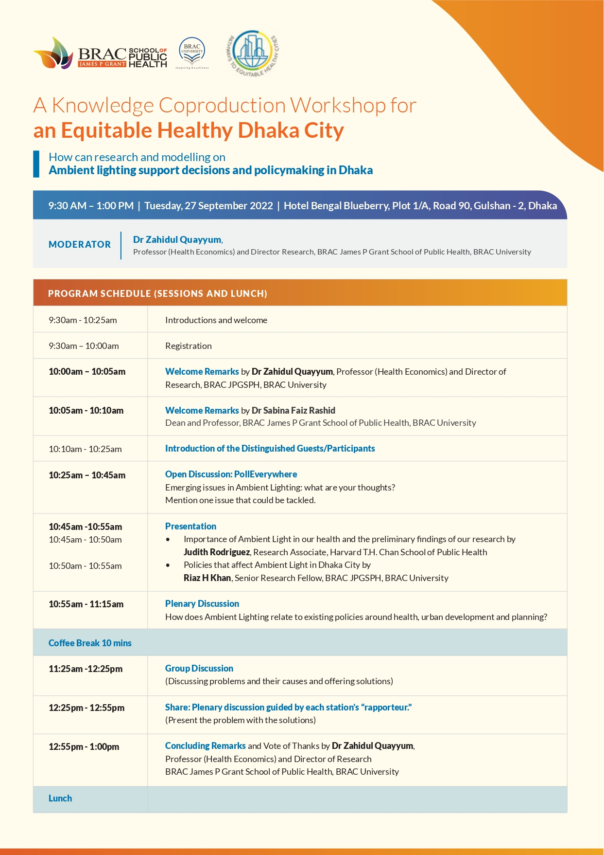
Annex 1: Program schedule

Annex 2: List of the participants
Sl | Name | Name of Organization | Designation
1 | Dr Aliya Naheed | ICDDR,b | Programme lead (Non-communicable diseases)
2 | Mohammad Fazle Reza Sumon | Bangladesh Institute of Planners | President (2022-2023) *current
3 | Mohammad Parvez Khadem | House Building Research Institute (MoHPW) | Principal Research Engineer
4 | Ms Nusrat Sumaiya Tani | Bengal Institute for Architecture, Landscapes and Settlements | Director, Research and Design Program
5 | Dr. Khandaker Shabbir Ahmed | BUET | Professor
6 | Dr. MD. Rasahed Bhuiyan | BRAC ARCH | Associate Professor
7 | Israt Jahan | Urban Development Department (UDD) | Planner
8 | ENGR. Md. Parvez Rana | DSCC | Assistant Engineer
9 | Dr Zahidul Quayyum | CENTRE OF EXCELLENCE FOR URBAN EQUITY AND HEALTH (CUEH) | Director
10 | Malabika Sarkar | BRAC JPGSPH | Professor and Associate Dean
11 | Judith Rodriguez | Harvard University | Senior Research Associate
12 | Frans Berkhout | King's College London | Professor
13 | Riaz Hossain Khan | BRAC JPGSPH | Senior Research Fellow
14 | Sabrina Mustabin Jaigirdar | BRAC JPGSPH | Deputy Research Coordinator
15 | Md. Kamrul Hasan | BRAC JPGSPH | Research Associate
16 | KhadizaTulKobraNahin | BRAC JPGSPH | Research Associate
17 | Anisur Rahman Bayazid | BRAC JPGSPH | Research Assistant
18 | JannatunTajree | BRAC JPGSPH | Research Assistant
19 | SwaksarAdhikary | BRAC JPGSPH | Research Assistant
20 | TanbiTanayaSarker | BRAC JPGSPH | Research Assistant

