Draft Report

A Knowledge Co-production Workshop for

an Equitable Healthy Dhaka City

Gendered accessibility and transport | How do we support

Policy in action?

28th April 2023

Prepared By

BRAC James P Grant School of Public Health, BRAC University

Introduction
BRAC James P Grant School of Public Health (BRAC JPGSPH) is conducting a research project titled "Pathways to Equitable Healthy Cities (PEHC)," funded by a grant from the Wellcome Trust, administered as a sub-award through the Imperial College London. This project is being implemented across six different cities (Beijing, Dhaka, Accra, Tamale, London, and Vancouver) worldwide in five countries (China, Bangladesh, Ghana, the United Kingdom, and Canada). This research project envisions advancing sustainable urban development that supports healthier lives for all. The research program focuses on inflicting policy changes for a healthier and sustainable Dhaka city through reviewing available data across several sectors (housing, air, noise monitoring, transportation, water, sanitation, waste management, etc.), policies, and their health outcomes on city dwellers. One of the project's main objectives is to develop and refine relevant sectoral policy scenarios in knowledge co-production. This is done through a systematic and iterative process of multi-partner engagement to identify actionable technical and Policy options for equitable, sustainable, and healthy urban development.
To develop and refine relevant sectoral policy scenarios in knowledge co-production, BRAC JPGSPH held three days of knowledge co-production workshops on Ambient Lighting, Air and Noise Pollution in Dhaka City, and Gendered Accessibility and Transport on the 27th, 28th, and 29th of September, 2022. The workshops aimed to jointly develop an action plan for co-producing knowledge on these issues, create and support existing links across institutions, researchers, and partners and identify and develop concrete opportunities for future scenarios.
The Workshop on "Gendered accessibility and transport: How do we support Policy in action "was held on 29th September 2022. The program schedule is provided in Annex 01. A total of twenty-one participants actively joined the discussion (See Annex 02 for the participants' list). The Workshop on the topic "Gendered accessibility and transport" started with a welcome note by Dr. Zahidul Quayyum, Professor (Health Economics) and Director of Research, BRAC JPGSPH, BRAC University, with a brief overview of the Pathways to Equitable Healthy Cities (PEHC) project and discussed the Workshop's objectives. Broadly the purposes of the discussion were to brainstorm and share thoughts regarding the institutional context around the Gendered Accessibility and Transport issues in Dhaka and to create and support existing links across institutions, researchers, and partners. Also, identify and develop concrete opportunities for future scenarios on Gendered Accessibility and Transport that align local issues and priorities with PEHC research, modeling, and Policy scenario planning.

The daylong Workshop consisted of a poll conducted among the present guests, a presentation by Dr. Aruna Shivkumar from Imperial College, London, and its discussion, followed by a group discussion, identifying problems and solutions around the topic, and presentations of the groups.

Open Discussion: Poll Everywhere
After a round of introduction of the guests, all participants responded to the poll "What are the major issues and concerns regarding gendered accessibility and transport in Dhaka city?"

The participants mentioned the below-listed issues and concerns that negatively influence the accessibility of the female population to public transport in Dhaka city:
● Lack of availability of women-friendly public transport
● Lack of safety and security for women
●Lack of women's participation in the design of transport systems, policies, and strategies
● Lack of gender responsiveness in terms of sitting arrangements inside buses
●Sexual Harassments at public transports
●Absence of land use planning in transport
●Poor Condition of public transport and bus stops, and
●Unauthorized parking

The responses mainly revolved around the poor conditions of the overall transport system, specifically technical problems with the poor quality buses, such as sitting, boarding, shelters, and stoppages; however, one participant highlighted how land use planning is missing from transportation. The scenario is worsened a lot by unauthorized parking and the poor condition of the sidewalks.
Not every citizen experience Dhaka streets the same way, as found in the answers to the poll. The roads are much unsafe and need to be more equitably responsive to the needs of women. They are often harassed on the streets on occasion and specifically at night; it is extremely dangerous for a woman's safety. Women also cannot utilize the available services the same way as men do, as these services have the least provisions for women's safety and comfortability. As a result, not all modes of transportation are used by women. This predominantly makes the cost of transportation higher for women.
To address women's access to transportation, a participant asked if they could be encouraged to use all modes of transportation, while another one called for attention from the BRTA to develop accountability for women's safety throughout various timings of the day.

What do research and scientific evidence say?
The poll was followed by a presentation by Dr. Aruna Sivakumar, Director, Urban Systems Lab & Reader, Centre for Transport Studies, Imperial College London, who provided an overview of the Workshop topic titled above, and described the aims of the research project. During the presentation, the presenter focused on the purpose of designing transport systems in a way that brings jobs and activities. Therefore, accessibility in the transport system is being considered with great importance globally. She shows how women are under-represented in the available but inadequate data. She concludes the presentation by emphasizing the need for a women-friendly transport system commensurate with their contribution to economic growth. The summary of the discussion and the guests' responses are presented below.

Transport accessibility for women in the public transport system has been a prevalent issue in Dhaka city for decades. The workshop participants drew on examples from the public bus services and mass transport system Metro Rail that has been recently opened for the public of Dhaka city. Ms. Nilima Akter from Dhaka Transport Coordination Authority, Ministry of Road Transport & Bridges (DTCA, MoRTB) mentioned that the bus service Dolanchapa was run exclusively for females. However, it was eventually shut down due to poor functioning and the very limited capacity of the service. Another participant, MST Moushumi Habib representing the Dhaka Mass Rapid Transit Development Project, affirmed that there would be one in six coaches reserved for women in the new Metro Rail. These responses were met with opposing views, stating a need for change in the perspective. Security and safety while moving should be considered with more priority than segregating women or other populations into groups during the designing and planning process of a transportation system. Ms. Akter indicated the much-needed research on the commuting pattern of working women to assess their needs and develop tertiary transport services to support the Metro Rail project while engaging more women in the planning process.

While more content dominated the discussion related to issues with the bus services and the most recent-metro rail, a pollution control officer from DTCA, MoRTB, Md. Mamunur Rahman reminded not to disregard the pedestrian conditions when discussing women's safety. He remarks that having pedestrian access ensures accessibility to mobility.

Brainstorm and co-produce knowledge | Group Discussion
In this part of the workshop, the participants were asked to sit and discuss in groups one of their chosen topics from the list generated from the open discussion session. Participants in three different groups identified the three most concerning issues affecting women’s access to transport facilities for brainstorming and discussion among the group members. The questions/ topics covered by the discussants were as below-

Group 01: Lack of participation of women in developing policies and strategies related to transports
Group 02: Lack of availability of women-friendly transport, and
Group 03: Lack of safety and security of women in transports

The summary of the causes of the problem, including the suggested solutions by the group participants under the above most concerning issues, are provided in Table 01(a-c) below.

Table 01(a): Root causes and suggested solutions for the lack of participation of women in developing policies and strategies

Causes behind the problem | Suggested Solutions
- Lack of bottom-up awareness approach  - Lack of consideration of women’s perspectives in the planning process  - Lack of infrastructure design aligning end-to-end needs  - Reluctance of transport industries  - Lack of practical data | - Awareness campaigns in different forms including schools  - Ensuring participation in the design of transport, programs, and policies  - End-to-end planning needs to be used with a set of methodologies (e.g., accessibility matrix)  - Women should be engaged throughout program and project design

Table 01(b): Root causes and suggested solutions regarding the lack of availability of women-friendly transports
Causes behind the problem | Suggested Solutions
- Lack of enough female coaches and enough fixed bus stops  - The attitude of drivers and helpers is not women-friendly  - Male Passengers are not supportive of the females  - Unavailability of enough dedicated sitting arrangements for women  - Passengers do not maintain queues and other traffic rules | - Number of public transport should be increased for women  - Changing the mindset and attitude of everyone (passengers, drivers, helpers)  - Raising awareness for women’s rights in public transport  - Drivers and helpers should be trained up  - Emergency phone number with bus registration number should be used inside the buses (for complaints)

Table 01(c): Root causes and suggested solutions regarding the lack of safety and security of women in transports
Causes behind the problem | Suggested Solutions
- The design of buses is not women-friendly (the doors and female sitting arrangements are usually on the engine side)  - Lack of enough passenger shelters  - Frequent sexual harassment on the public transport  - Unavailability of women drivers and lack of availability of women in the management of transport system  - Bus stops are not in close proximity to residents and educational institutions | - Buses should be redesigned (e.g., doors should be in the middle)  - Women drivers should be recruited  - Women’s participation and engagement should be ensured in the management of the transport sector  - Complaining system should be available and proper monitoring needs to be ensured  - Enforcement of laws against sexual harassment and proper monitoring of its implementation

The participants constructed a problem tree and flipped it to look at the solutions or approaches available to them to address the problems they identified. Much of the obtained results overlapped among the discussants; however, the main issues identified were the lack of availability of women-friendly transport and lack of gender aspect in the design of a transport system, making it very challenging for women to commute in the public transport services. Some of the issues are structural, such as unfavorable sitting arrangements, pick-up/ drop-off provisions for women, negative attitude and harassment from the male driver, conductor, supervisor, and even passengers, unsafe conditions, and poor management of the bus stoppage for women and children, due to a lack in the monitoring of harassment and such issues in the public places. As a result, the guardians feel constant pressure regarding their safety and the school-going children, especially girls and adolescent girls.

Similarly, females are also under-represented in the overall transport system and services. There is only a limited number of female drivers, engineers, and trained professionals in the design and planning processes. To put off pressure from one mode of transport, there still need to be viable alternatives worthy of promotion. The lack of separate and safe bicycle lanes leaves commuters with no incentives and struggling emerging cyclist communities to keep to their hobbies.

Simultaneously, the workshop participants proposed solutions to the problems they identified and those called for including more women in the design, planning, decision-making, and management processes. More stoppages, passenger shelters, and regulated activities on the pedestrian streets, with a sustainable monitoring system to control harassment and punish offenses, additional information, and help lines are needed to support the need of female commuters in the transport system.

Reflections and Conclusions

Different types of vehicles are available in Dhaka city, including public and private buses, private cars, rickshaws, motorbikes, bicycles, laguna, water vehicles, and metro rail services. However, mobilization of the people within Dhaka city is often challenged by low-quality transport, un-trained drivers, undiscerned fare, lack of proper stoppage, and many others. One significant concern is that the public transport system is still not in good shape for different gender and age groups. Therefore, the workshop participants tried to elucidate various issues and concerns regarding gendered accessibility to transport services in Dhaka city through stepwise interactive discussion sessions. The attendees identified several root causes and proposed solutions for the most concerning issues hindering gender equality from getting access to transport services. There are existing policies, including National Integrated Multimodal Transport Policy (NIMPT) 2013, Strategic Transport Plan for Dhaka (2016-2035), Bus Rapid Transit (BRT) Act 2017, Mass Rapid Transit (MRT) Act 2016, Road Transport Act 2017, regarding urban transport, but their implementation needs to be improved by the implementing authorities. The existing rules and regulations should incorporate gender accessibility for urban transport planning.

At the end of the group discussions, Dr. Zahidul Quayyum delivered the concluding remarks and thanked all the attendees for participating in the workshop.

Annex 1: Program schedule
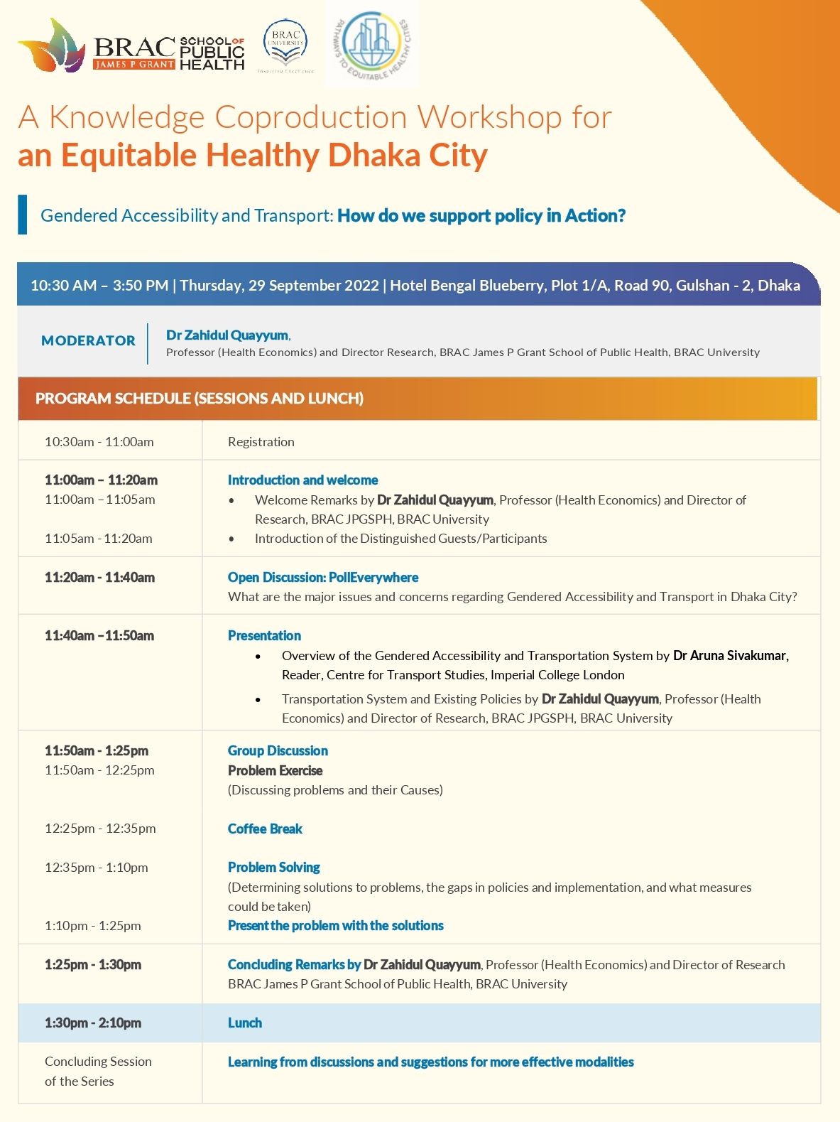

Annex 2: List of the participants

SL | Name | Name of Organization | Designation
1 | Md. Moniruzzaman | Asian Development Bank (ADB) | Associate Project Analyst
2 | ASM RaihanulFerdous | Capital Development Authority of the Government of Bangladesh (RAJUK) | Chief Engineer (Project and Design)
3 | Mr. MD. Haidor Ali | Dhaka South City Cooperation, Transport Division | General Manager
5 | Neelima Akhter | Dhaka Transport Coordination Authority, Ministry of Road Transport & Bridges () | Executive Director (Additional Secretary) (Additional Charge)
6 | MozammelHaque Chowdhury | Bangladesh Jatri Kalyan Samity | Secretary General
 | (on behalf) EnamulHaque | Dhaka Mass Transit Company Limited (DMTCL) | Engineer
8 | MST Maushumi Habib | Dhaka Mass Rapid Transit Development Project (Line-6) | (Deputy Secretary) Deputy Project Director (Public Relations) (Additional Charge)
9 | Md. Mohirulislam Khan | BRT (Gazipur to Airport) | Project Director, BBA
10 | MD. ZiaulHoque Chowdhury | PWAB | Member
11 | ENGR. Md. Parvez Rana | DSCC | Assistant Engineer
12 | Md. Mamunur Rahman | Dhaka Transport Coordination Authority, Ministry of Road Transport and Bridges | Pollution Control Officer
13 | Mahmodul Hasan | PWAB
14 | DrZahidulQuayyum | CENTRE OF EXCELLENCE FOR URBAN EQUITY AND HEALTH (CUEH) | Director
15 | Judith Rodriguez | Harvard University | Senior Research Associate
16 | FransBerkhout | King's College London | Professor
17 | ArunaSivakumar | Imperial College of London | Director, Urban Systems Lab
18 | SmruthiBala Kannan | University of Chicago
18 | Riaz Hossain Khan | BRAC JPGSPH | Senior Research Fellow
 | FarzanaSehrin | BRAC JPGSPH | Research Fellow
18 | Sabrina MustabinJaigirdar | BRAC JPGSPH | Deputy Research Coordinator
 | Baby Naznin | BRAC JPGSPH | Senior Research Associate
18 | Md. Kamrul Hasan | BRAC JPGSPH | Research Associate
18 | KhadizaTulKobraNahin | BRAC JPGSPH | Research Associate
18 | Anisur Rahman Bayazid | BRAC JPGSPH | Research Assistant
19 | JannatunTajree | BRAC JPGSPH | Research Assistant
20 | SwaksarAdhikary | BRAC JPGSPH | Research Assistant
21 | TanbiTanayaSarker | BRAC JPGSPH | Research Assistant

